BOS and com30 boot
Brief description
BOS and com30 are both used in boot code and application, the diagram shows Bos com30 tasks relationship in boot code, application use similar way. The PC communicate to vending machine by RS232 or USB serial driver According the destination of the message from Cl_Server, com30_in_task will send the message to local or remote bos_driver_task by i_send function, the remote message is redirect to remote host by gateway though 485 bus. Similar mechanism is used when session respond message to CL_server.
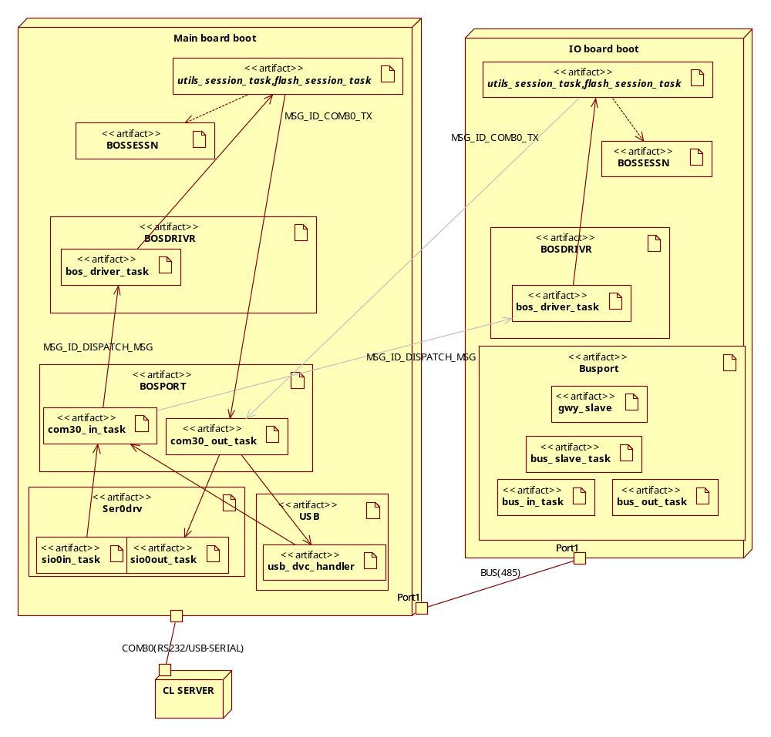

Ser0Drv

sio0in_task
for MainBoard

Note: receive serial data, and enqueue it to eRTXQSio0In, which will be read by com30_in_task(#define INPUT_QUEUE= eRTXQSio0In)

sio0out_task
dequeue from queue with eRTXQSio0Out and send to serial port,
the data is from com30_out_task (#define OUTPUT_QUEUE eRTXQSio0Out)

rx0_232_int
Called by Interrupt procedure _isvcrx0_232(Isrs.asm), then send data to sio0in_task
Tx0_232_int
?? why ram in Isrs.asm
Called by _isvcrx0_232(Isrs.asm)to let sio0out_task continue to send

isvcrx0_232, isvcrx1_232
Location: Isrs.asm
Note: interrupt service function for serial, which will call c function rx0_232_int to process the received data

rx0_232_int
receive data and put into buffer, called by isvcrx0_232

usb_dvc_handle
Startup when not PCB388
input : eRTXQSio0In
output: eRTXQSio0Out
Is that mean the bootcode surports both real serial port and USB(usb-serial) ?

Bosport
com30_out_task

com30_in_task
#define INPUT_QUEUE eRTXQSio0In
receive data from lower serial layer; assemble to CMessage format, and
after got the STOP_CHAR , check the CRC and send the CMessage message to bos_driver_task.
Note: com30_in_task will resend the data it got from eRTXQSio0In to eRTXQSio0Out,until it can determine the message is for itself.

send_to_bos_driver
send the message to the local or remote bos_driver_task
CMessage change to COM30_EMB_MSG_STRUC
Message id MSG_ID_DISPATCH_MSG

Bos driver (bosdrivr)
which is responsible for starting several tasks, and receiving incoming com28 and com30 messages from the com30_in_task. The incoming message are handled by dispatching them, by calling he right functions of other bos sessions.
Task: bos_driver_task
driver_dispatch_message
dispatch message
message type: PT_CMD, PT_CMD, PT_ERR

add_session

bossessn
bossessn.c contain tools functions for session tasks(utils,flash)
- Handling incoming commands, errors and responses
Get and send through session commands, errors and responses
Creating sessions
(Destroying sessions) Never used.
session_create
session_create
ses_get_command

utilsses.c
- utilitiy functions (reset, query appl. descriptors, memory dump, pump, etc)
utils_session_task

Flessessn.c
- flash or ram application programming
flash_session_task

Process_command
r_first_download

Commutation
typedef struct
{
DWORD dst;
DWORD src;
BYTE taskNr;
BYTE packetType;
BYTE seqNr;
BOOLEAN isHeaderCrcOk;
WORD error;
WORD dataLength;
#if _MODEL != 'l'
_huge BYTE *pData;
#else
BYTE *pData;
#endif // _MODEL != 'l'
BOOLEAN headerValid;
BOOLEAN destroyAfterSent;
BYTE retryCount;
BOOLEAN isScreambled;
BOOLEAN headerScreambled;
size_t dataCount;
size_t dataIndex;
BYTE data[MSG_DATA_SIZE];//the real data content need to send
} CMessage;

START [CTRL_CHR]* [*]*CTRL_CHR

CRC
SEQUENCE

BOS and com30 Application

Where is the bos code of application
com30.h define com30 command and errorcode

Main.c->start_sessions-> start_bos_tasks
XA_xRTXC\BosDrv
XA_xRTXC\FileSes
XA_xRTXC\UtilSes

Commio.c
CCommIOCtxt* add_comm_io_intrf(CCommIOCtxt* pCtxt, CCommIOSUArgs* pArgs)
Register interface

CCommIOCtxt* comm_io_get_intrf(CCommIOCtxt* pCurrCtxt, ECommApplType applType, TICKS huntTime)
Get interface

static CCommIOCtxt* comm_sio_init(CCommIOCtxt* pCtxt, CCommIOSUArgs* pArgs)
initial serial interface
comm_sio_init, comm_sio_open,comm_sio_read …

Extconf.c ->
ExtStartComm.c->ext_comm_start ->tcp_handler ->gvmc\tcpip\Tcpcom30.c\void TcpCom30Init(void)

Xa_xrtxc\Sio_int.c

Bosport.c
static BOOLEAN rx_event_frame(CRxFrame *pRxFrames)
regester as a callback function in fun->fpOpen interface,called by the io layer when data receive.

Xa_xrtxc\Siodrv.c\void sio_init(DEV_INIT_PACK *init_pack)
pdu->header.dev_sema = init_pack->dev_sema;
\xa_xrtxc\RTXiocnf.c
const DEV_INIT_PACK dev_init_tbl[NLDEVS + 1] =
…
{ SIO_ID, SIO0_IN_DEV, 0, sio_init, SIO0IRES, SIO0ISEM, ATTB_READ },

THREE LISTENER
Tcpprog.c/_pcbProgListen
Tcpeva.c _pcbEvaListen
Tcpcomm30.c/ _pcbCom30Listen
Lwpip\src\api\Api_msg.c

COMMONIO
Common io interface, contain interfaces to manage io of tcpip,serial and other devices
add_comm_io_intrf
comm_io_add_device

tcp => bosport.c/rx_event_frame
- send_to_bos_driver
- send to pidBosDrv,pidBosDrv may be local or remote

